Lab Report 2: Percent Turbulence of the Subsonic Wind Tunnel
Nathaniel L. Holmes
North Carolina State University, Raleigh, NC, 27607

Nomenclature
Re = Reynolds number of the wind tunnel
C_{p} = pressure coefficient
TF = turbulence factor
ΔP ₌ differential pressure (Pa)
I = transducer current (mA)
ρ = given density (1.185 )
μ = given coefficient of dynamic viscosity of air ()
d = diameter of the turbulence sphere (0.2032 m)
v = velocity in the wind tunnel

Introduction
The aim of this experiement was to determine the percent turbulence in North Carolina State University’s subsonic wind tunnel. A turbulence sphere was placed in the wind tunnel to collect the readings during the experiment. Representing the calibration of the wind tunnel’s pressure transducer, the linear equation (Eq. 1) from last lab was again used in this experiement.

Procedure of Experiment
A turbulence sphere was placed in the subsonic wind tunnel after which pressure and amperage readings were collected from the wind tunnel pressure transducer. Steps of 0.5 psf were used in the collection of the current readings, which started at 0.5 psf and ended at 15 psf, for a total of 30 readings per run. Data was collected over four days, each of which held two runs, for a total of eight data sets. The data from all sessions was included in the calculation of turbulence factor and percent turbulence of NCSU’s subsonic wind tunnel.

Data Analysis
All data was converted from the Imperial system of units to SI units for all calculations and considerations after the initial collection of data.

Anomalies
Both of Wednesday’s sessions, in addition to Thursday’s second run, were missing the initial data point corresponding to the pressure reading of 0.5 psf. To counteract this anomaly, the data point from Tuesday’s first session was included as a data point in those three instances. Another anomaly in the data set can be noted as the first data point of Wednesday’s first run, which is due to an unusually high current reading of 4.634 mA, while the other sessions read the current to be around 4.5 mA. This anomaly was left in place in the data set and can be seen clearly in Fig 1.
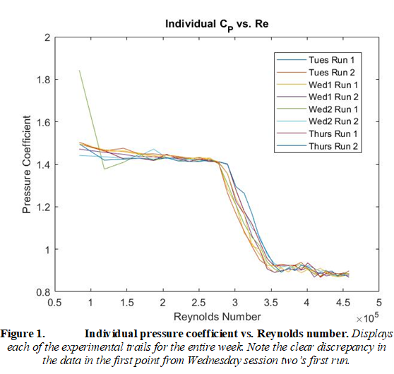

Calculations
From lab one, the calibration of the wind tunnel pressure transducer can be modelled by the curve Eq. 1. This calibration curve was used to find the pressure difference over the sphere by plugging in the recorded current values from the transducer. To find the pressure coefficient, these data points for differential pressure were divided by the corresponding recorded data points for the pressure in the wind tunnel.

(1)

Velocity was calculated first using Eq.2, and then Reynolds number was calculated using Eq.3. Plotting the calculated average coefficient of pressure values against Reynolds number yields Fig.2.

 | 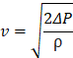 | (2)
 | 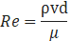 | (3)

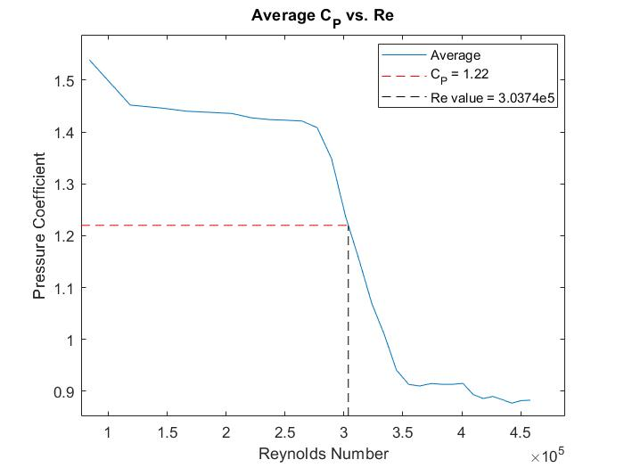
Figure 2. Average pressure coefficient vs. Reynolds number. Shows the average plot of all the data as well as the reference lines for the critically-associated coefficient of pressure and corresponding Reynolds number value.

Interpolating between points on the graph, the Reynolds number for the wind tunnel related to the critical pressure coefficient, 1.22, is found to be 3.0374 x . The turbulence factor (TF) is then calculated using Eq.4, which then results in a TF of 1.2675 for the wind tunnel. The is an experimental value for the Reynolds number of a sphere in a freestream environment that relates to the same 1.22 pressure coefficient.

 | 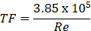 | (4)

From the given experimental data in Fig. 3 from the lab handout and another interpolation calculation from starting point (1, 0) to ending point (1.5, 6), where the x-values are the TF and the y-values are the percent turbulence, the resultant turbulence percentage for the wind tunnel is 0.3210%. This is a low number, especially compared to the trend shown in Fig. 3, indicating that there is not a great deal of turbulence in the NCSU subsonic wind tunnel.

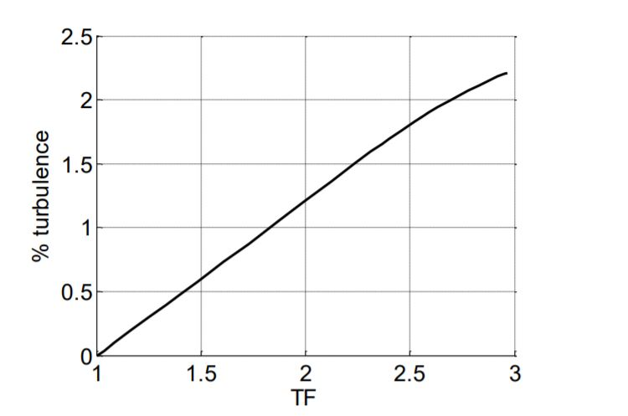
Figure 3. Magnetization as a function of applied field. From the lab handout document, this is the graph that was used as a source of interpolation data.

Conclusion
Excluding the one exception, all data points had low variation, and when averaged together, resulted in a low turbulence percentage for the wind tunnel. Trends such as these exhibit the levels of reliability and accuracy of the subsonic wind tunnel. For the best results, many trials should be done to eliminate what variation and also to prevent the data set from being scewed by an outlier, such as the one from Wednesday in this experiement.

Appendix

dat1 = load('tuesrun1.dat'); % tues run 1
dat2 = load('tuesrun2.dat'); % tues run 2
dat3 = load('wed1run1.dat'); % wed1 run 1
dat4 = load('wed1run2.dat'); % wed1 run 2
dat5 = [dat1(1,:);load('wed2run1.dat')]; % wed2 run 1, concatenated because is missing first element
dat6 = [dat1(1,:);load('wed2run2.dat')]; % wed2 run 2
dat7 = load('thurrun1.dat'); % thur run 1
dat8 = [dat1(1,:);load('thurrun2.dat')]; % thur run 2

matdat = {dat1,dat2,dat3,dat4,dat5,dat6,dat7,dat8}; % cell for loop
% preallocating loop variables
pdat = (1:length(dat1))';
idat = pdat;
% loop to combine data
for i = 1:8 % 8 data files
file = matdat{i}; % current element in matdat
pdat(:,i) = file(:,1); % column of pressure
idat(:,i) = file(:,2); % column of current
end
% averaging data
bigdat = [mean(pdat,2),mean(idat,2)]; % averages the rows of the pressure and current and then concatenates them

%p0 = 101325; % SSL pressure, Pa
p0 = 97773;
rho = 1.185; % Given density, kg/m^2
visc = 1.831e-5; % air dynamic viscosity
d = 0.2032; % given diameter of sphere (acts as chord), meters

p = bigdat(:,1).*47.88; % WT pressure
I = bigdat(:,2); % amperage from transducer used to get pressure in WT , mA

% used increasing velocity linear fit from last lab (ampfiti) I = 0.0123*p + 4.0695
% to get pressure total
pfit = @(x) 1./0.0123.*(x - 4.0695); % anonymous function used for repeat
deltaP = pfit(I); % pressure difference over sphere

% Calculating q and Re
% p1 is freestream dynamic pressure (q1)
v = sqrt(2.*p./rho); % velocity for Re calc
Re = rho.*v.*d./visc; % Reynolds number

% Re calcs (out of order a bit, used for plot below)
wtRe = interp1([Cp(13),Cp(14)],[Re(13),Re(14)],1.22,'linear'); % Wind tunnel Reynold's number from
% interpolation when Cp = 1.22
critRe = 3.85e5; % Predefined experimental critical Reynold's number for sphere
TF = critRe./wtRe; % Turbulence factor for the wind tunnel
% Plotting deltaP/q vs. Re
figure(1)
Cp = deltaP./p;
plot(Re,Cp);
title('Average C_P vs. Re');
xlabel('Reynolds Number');
ylabel('Pressure Coefficient');
hold on
plot([0,wtRe],[1.22 1.22],'--r')
plot([wtRe, wtRe],[0, 1.22],'--k'); % plots vertical line at intersection point
legend('Average','C_P = 1.22','Re value = 3.0374e5')

% From Fig.3: Data for TF Percentage used are the two points closest to TF
% value of 1.2675, which is the result of the above TF calculation
x1 = 1; % starting point TF
x2 = 1.5; % ending point TF
per1 = 0; % starting point turbulence percent
per2 = 0.6; % ending point turbulence percent
percentTF = interp1([x1,x2],[per1,per2],TF,'linear'); % interpolating between the points at x-value 'TF'

% Individual plots
figure(2)
%1
p1 = dat1(:,1).*47.88;
I1 = dat1(:,2);
deltaP1 = pfit(I1);
plot(Re,deltaP1./p1);
hold on
%2
p2 = dat2(:,1).*47.88;
I2 = dat2(:,2);
deltaP2 = pfit(I2);
plot(Re,deltaP2./p2)
%3
p3 = dat3(:,1).*47.88;
I3 = dat3(:,2);
deltaP2 = pfit(I3);
plot(Re,deltaP2./p2);
%4
p4 = dat4(:,1).*47.88;
I4 = dat4(:,2);
deltaP4 = pfit(I4);
plot(Re,deltaP4./p4);
%5
p5 = dat5(:,1).*47.88;
I5 = dat5(:,2);
deltaP5 = pfit(I5);
plot(Re,deltaP5./p5);
%6
p6 = dat6(:,1).*47.88;
I6 = dat6(:,2);
deltaP6 = pfit(I6);
plot(Re,deltaP6./p6);
%7
p7 = dat7(:,1).*47.88;
I7 = dat7(:,2);
deltaP7 = pfit(I7);
plot(Re,deltaP7./p7);
%8
p8 = dat8(:,1).*47.88;
I8 = dat8(:,2);
deltaP8 = pfit(I8);
plot(Re,deltaP8./p8);

title('Individual C_P vs. Re');
xlabel('Reynolds Number');
ylabel('Pressure Coefficient');
legend('Tues Run 1','Tues Run 2','Wed1 Run 1','Wed1 Run 2','Wed2 Run 1','Wed2 Run 2','Thurs Run 1','Thurs Run 2');

